Please have each child that has registered for camp go to https://bit.ly/campclubs2023 or scan QR code to pick their top four clubs for Kentucky Kids Camp. We have added BB guns this year. The BB gun range will be run by an NRA instructor. Your child must be at least 9 years old to participate in BB guns. Children participating in the BB gun club will be required to have a parent/guardian fill out an extra permission form. The permission slip will be sent out after the selections are made.

Here is a list of clubs:
Outdoor Sports
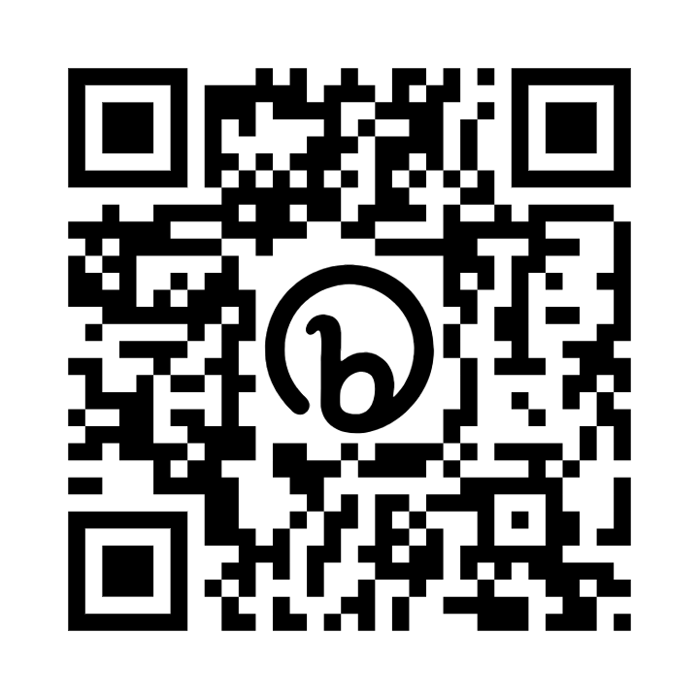
Hiking
Archery
BB Guns
Woodworking
Cake Decorating
Photography
Crafts
Painting

